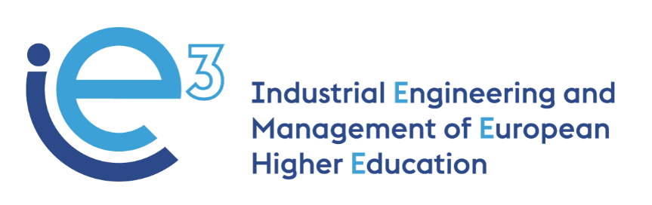



**R3.4 IE3 courses final version**

**-----------------------------------------------**



The European Commission support for

the production of this publication does

not constitute endorsement of the contents

which reflects the views only of the authors,

and the Commission cannot be held

responsible for any use which may be made

of the information contained therein.

The final version of the IE3 courses is available on the IE3 website, under the section "results".

* [“Operations Management in Advanced Lean Systems” – Polytechnic University of Bari](https://ie3.eu/polytechnic-university-of-bari-university-of-bari-aldo-moro/):
  + Operation and Performance Measure;
  + Lean System and Continuous Improvement;
  + Production Planning and Control;
  + Inventory Management;
  + Advanced Lean System.
* [“Supply Change Management” – Poznan University of Technology](https://ie3.eu/poznan-university-of-technology-renewed-course/):
  + Industrial visit. Data from Alcomot;
  + Risk analysis. Supply chain design and analysis;
  + VSM workshop.
* [“Project management: Advanced Tools and Techniques” – Technical University of Madrid](https://ie3.eu/technical-university-of-madrid/):
  + Introduction;
  + Digitalization and Projects;
  + Project Management Methodologies;
  + Scope Management;
  + Time and Cost Management;
  + Project Execution Monitoring;
  + Risk Management;
  + Quality Management;
  + Communication and Stakeholder Management;
  + Agile Porject Management;
  + Management of the R&D projects;
  + Maturity Models.
* “Design and Development of Manufacturing Operations” – [Linköping University](https://ie3.eu/linkoping-university-2/):
  + System Relationships;
  + System Design;
  + System Simulation;
  + Pitfalls and help in Simulation;
  + Setup time reduction, Task C;
  + System Knowledge, Task D;
  + PicSim Summary;
  + AI and Machine Learning (lecture);
  + AI and Machine Learning (seminar).