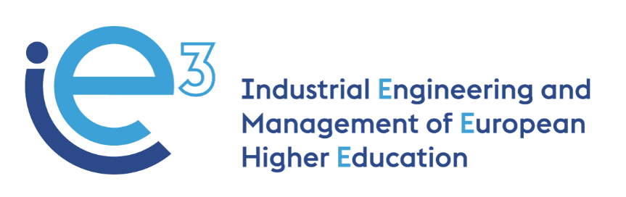



**IE3_11th Virtual Meeting  
11.06.2021**



The European Commission support for the production of this publication does not constitute endorsement of the contents which reflects the views only of the authors, and the Commission cannot be held responsible for any use which may be made of the information contained therein

**Participants:**

* POLIBA, represented by Giovanni Mummolo, Giorgio Mossa, Salvatore Digiesi and Francesco Facchini
* PUT, represented by Agnieszka Stachowiak and Joanna Oleskow-Szlapka
* LIU, represented by Mathias Henningsson and Fredrik Persson
* UPM, represented by Joaquin Ordieres
* VALUEDO, represented by Giuditta Pasta
* BOSCH TDIT, represented by Felice De Stena and Nicola Masellis
* INFOTECH, represented by Gianluigi De Pascale
* IMPLEMA, represented by Eskil Rehme
* ALCO-MOT, represented by Hanna Golas
* ARRUTI, represented by Carlos Uruena

**Agenda:**

* WP3: updates on the revision process of the training courses - LiU
* WP4: discussion on the WP4 document shared by UPM - UPM and all partners
* Updates on the Interim Report preparation - PoliBa and ValueDo

**WP3: updates on the revision process of the training courses - LiU**

The meeting starts with the presentation of the agenda by Prof. Mummolo.

Henningsson (LiU) updates the partners on the revision progress of the training courses. They have held one course in the previous period together with the Swedish company of the consortium, Implema. During this experience, LiU tried to give the students important inputs from reality, but they had to organize virtual lecturers. The feedback from the students was very positive and they received interesting impacts to improve the course next year. They did also some small changes and they gathered good experience for the next year.

Persson (LiU) informs that there is a project that lasts for the whole duration of the course: the focus is to incorporate more artificial intelligence. Thanks to the help and contribution from Implema, they have organized a seminar and a lecture within the course. The lecture was about what you can do and the seminar was focused on the feelings and impressions of students on the different types of Artificial Intelligence. This course is now under evaluation, but at LiU they have already a good idea of what can be changed thanks to the feedback from students.

Henningsson (LiU) adds that they are also working on a new course that will be performed in autumn 2021; they will adopt a more advanced approach and everything will be adapted and improved also to the feedback received by the students.

Mummolo (POLIBA) asks when LiU expects to receive feedback from the students.

Henningsson (LiU) replies that they expect to receive it within 3 weeks after the end of the course. However, they expect to collect a low number of answers, because summer break is close and so they think they will gather between 15% and 30% of answers. He adds also that the evaluation is not mandatory at their university.

Mummolo (POLIBA) informs that at Polytechnic of Bari the situation is quite different: the summer break is not so close (it will be in August) and the students' evaluation on the courses is mandatory, so they expect to receive more feedback than LiU.

**WP4: discussion on the WP4 document shared by UPM - UPM and all partners**

Ordieres (UPM) starts presenting the document for the WP4 Action Plan (the full document is available here). Since in WP4 all the four academic partners of the consortium will be involved, the local legislation, local culture and local restrictions need to be considered. The Universities, indeed, are located in four different countries with learning environments that are, following academic traditions, very differentiated. Because of this, it is not possible to launch an action plan that is meant to be followed by each partner in the same way.

By respecting the local culture and way of providing value for each revised course module, the goal is to decide how they will be configured as asynchronous based learning objects. Therefore, there are a set of preliminary decisions impacting on digital platform which is worth making clear from the very beginning.

The WP4 Action Plan does consider all the engagements involved in it. Mainly:

1. The description of the modules transformed for e-learning
2. The pedagogical model beyond the e-learning implementation
3. The intended usage of the platform by learners (duration, foreseen interactions, etc.) These aspects are closer to the selected methodology
4. Which non-standard elements must be required (gamification, etc.)
5. The added value (strengths) the e-learning module provides. This is relevant as other partners can decide to cross use it because of your description. To summarize the strengths in several bullet points is highly recommended
6. The content Creation
7. The behavioural tests

Mummolo (POLIBA) asks for more information about “T4.1 - Setup the technical environment for the e-learning system, including serious gaming and learning routes extensions”.

Ordieres (UPM) replies that for this task the partners will be required to provide the following information: **Existing Course Module to be Revised for e-learning and Intended usage of the platform by learners.**

After a brief discussion on the timeline proposed by Ordieres (the proposal was based on the project application), the partners agree on the following one:

* Task 4.1 (3 months. May – July 2021). It will require the elements a) and c) from academic partners by the end of July;
* Task 4.2 (2 months. July – September 2021). It will require the elements b), d) and e) from academic partners by the end of September;
* Task 4.3 (4 months. September – December 2021). It will require the elements f) from academic partners regularly along the period;
* Task 4.4 (3 months + 2 months to accommodate course schedule: January – May 2022) and Task 4.5 (1 month May 2022). It will require the elements g) from all partners by the end of May 2022;
* Task 4.6 (3 months. May – July 2022). An overarching report regarding the implemented changes, to be added to the previous elements of information.

**Updates on the Interim Report preparation – PoliBa and ValueDo**

Giuditta (VALUEDO) informs the partners that the Interim Report is at a very good point: the technical parts have been completed and at the moment PoliBa, supported by ValueDo, is working on the financial report. The Interim Report must be submitted by the end of June. She informs that in the following weeks the partners will be contacted by Ivano Recchia (administrative responsible at PoliBa) to adjust the financial documents sent if needed. De Pascale (INFO) adds that he’s finalizing the Interim Dissemination Report and the section *“4.1 Dissemination. Please use this space to review the information on short-term targets (number of people reached and strategies for reaching them during the life of the project) that you provided in annex I of your grant agreement including all dissemination activities. Please describe how the target groups (including participating institutions, stakeholders) have been reached and involved during the project lifetime and comment on how the project have benefited the target group at local, regional, national and or European level. Provide details of confidential results, intellectual property rights' issues, copyrights, potential commercialisation (where applicable). Include login and password details for any confidential areas of the project website/s, private stakeholders (enterprises, association, etc...). Comment also on the tools used (website, flyers, conferences, meetings, visits, co-operations established etc.) and how you promoted and ensured the visibility of your project?”* for the Interim Report.

Mummolo (POLIBA) adds that on 3rd June 2021 he participated, on behalf of IE3 project, at the “Higher Education Transformation Agenda”, with all the Knowledge Alliance projects funded with the last calls. He underlines that, during the Consultation Break-out discussion, one of the main findings is the importance of the role of companies and the soft skills within this kind of projects.

De Pascale (INFO) will upload the information gathered by professor Mummolo on the Consultation Break-out discussion on the IE3 website.