****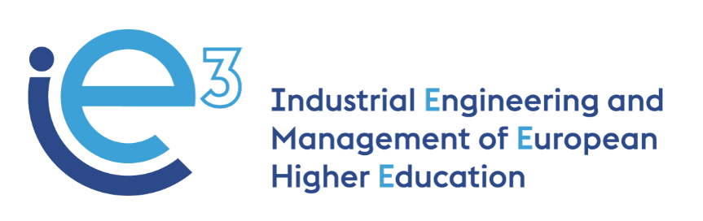



**IE3_14th Virtual Meeting  
30.11.2021**



The European Commission support for the production of this publication does not constitute endorsement of the contents which reflects the views only of the authors, and the Commission cannot be held responsible for any use which may be made of the information contained therein

**Participants:**

* POLIBA, represented by Giorgio Mossa and Francesco Facchini
* PUT, represented by Marek Fertsch, Agnieszka Stachowiak and Joanna Oleskow-Szlapka
* LIU, represented by Janerik Lundquist, Mathias Henningsson and Fredrik Persson
* UPM, represented by Joaquin Ordieres
* VALUEDO, represented by Alessandro Guadagni and Giuditta Pasta
* INFOTECH, represented by Gianluigi De Pascale
* BOSCH TDIT, represented by Felice De Stena and Vincenzo Ciannamea
* ALCOMOT, represented by Hanna Golas
* IMPLEMA, represented by Eskil Rehme
* ARRUTI, represented by Carlos Uruena
* Invited: UNIBA, represented by Giovanni Mummolo

**Agenda:**

* Selection of the modules to be turned into e-learning course;
* Contribution of the companies for the preparation of the modules.

**Selection of the modules to be turned into e-learning courses**

Mossa (POLIBA) starts the meeting by asking the partners to check whether their institutions have received the second installment. The Italian partners confirm that they have received the payment on their bank accounts, while the others will check soon.

The University partners present the modules they have selected that will be turned into e-learning lessons for the IE3 course.

* **LIU** will prepare the module **“Artificial Intelligence in Operations Management”.** The main topics to be addressed are Difference between AI and machine learning, Decision making, Machine learning in operations management, Machine Learning exercise. POLIBA team finds these topics useful for their module "Decision theory" (2 ECTS): Decision making under conflict, risk and uncertainty; while UPM adds that this module is a very good complement to reinforce concepts of their advanced operations management course.
* **POLIBA and UNIBA** proposed two modules: **“Lean systems and continuous improvement” and “Advanced Lean Systems: Pull & Levelling Tools”.** The two modules will be merged in order to create a course that could be useful for all the partners. For the more advanced concepts, POLIBA can surely benefit from the BOSCH experience (factory case studies). LIU comments that the advanced concepts will be very interesting in their advanced level course in MPC where they look at VSM and other Lean tools. The course will be developed in order not to require much knowledge to be completed and to meet the needs of the UPM students’.

PUT has lean courses in its offer and it would be interesting to enrich the training offer with additional material. They find POLIBA’s approach very practical (especially the aspect of lean re-engineering is interesting as it is new and not usually included).

* **PUT** suggests two modules: **“Closed-loop material flows in the supply chain” and “Competences matrix for manufacturing employees (agile approach)”**. PUT intends to share case studies and practical tools with students, so they will get support from ALCOMOT for preparing use cases. The objective is to train students about how to regain and recover value from the materials flow. This will embed both quantitative and qualitative approaches and will require flexibility and adaptability skills.
* **UPM** proposes to design and deliver the module on **“Project Monitoring”.** The main topics to be addressed will be the following: Project Success, Monitoring Earned Value / Earned Schedule, Forecasting the project Evolution, Decision Making from the Customer point of view. The module will be developed in a micro-learning approach and it should be ready in January 2022. POLIBA adds that these topics can be useful for their module "Decision theory (2 ECTS): Decision making under conflict, risk and uncertainty. Project Planning and Control".

The final modules that will compose the course are the following (one prepared by each University partner with support from the companies):

* *POLIBA: one module that combines the two proposed, “Lean systems and continuous improvement” and “Advanced Lean Systems: Pull & Levelling Tools”;*
* *LIU: “Artificial Intelligence in Operations Management”;*
* *PUT: “Closed-loop material flows in the supply chain”;*
* *UPM: “Project monitoring”.*

**Contribution of the companies for the preparation of the modules**

While working on the selection of the modules for the e-learning course, all the universities have already contacted the national companies in order to understand which contribution they could give to the preparation of the training materials. The companies can give support transnationally: the universities are free to contact all the companies of the consortium (not only one of the same country) when preparing the materials to get feedback and suggestions. In this way, the alliance between the academic world and industrial world will be strengthened and the purpose of the project reached.   
Mummolo (UNIBA) points out that also UNIBA could involve some economics students for participating in the course.

For the recruitment of the students, the Universities should decide how to gather subscribers. For the pilot of the course, at least 15 students per university should be involved.

UPM is in charge of preparing the evaluation questionnaires, both for students and for companies, in order to collect different points of view and different information.

The partners discuss the involvement of the partner companies in the testing phase of the course and they agree to keep two open possibilities for them:

* At least one company’s employee takes all the e-learning modules in February 2022 (two weeks) before the pilot test with students between March and June 2022 (in which also other employees could participate), to provide formal feedback to the Universities upon the whole course;
* The company partners will go through the learning materials without taking the course before the official pilot. Then, they will assess the full course in the same period as the students (March-June 2022) and they will be asked to evaluate it through the questionnaires prepared by UPM.

*Next deadlines and work-plan*:

* All University partners to prepare a draft of the syllabus by 14.12.2021;
* All University partners to prepare the first draft of the training materials by 31.01.2022;
* All University partners and companies give feedback to the training materials by 14.02.2022;
* All University partners to release the final version of the training materials by 28.02.2022;
* The pilot of the course between March and June 2022.