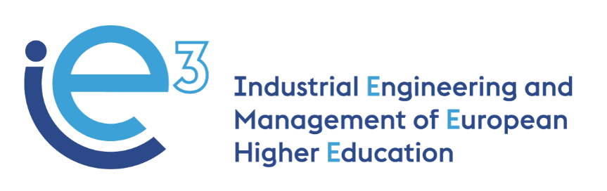



**IE3_15th Virtual Meeting  
11.02.2022**



The European Commission support for the production of this publication does not constitute endorsement of the contents which reflects the views only of the authors, and the Commission cannot be held responsible for any use which may be made of the information contained therein

**Participants:**

* POLIBA, represented by Giorgio Mossa, Salvatore Digiesi and Francesco Facchini
* PUT, represented by Agnieszka Stachowiak and Joanna Oleskow-Szlapka
* LIU, represented by Mathias Henningsson and Fredrik Persson
* UPM, represented by Joaquin Ordieres
* VALUEDO, represented by Alessandro Guadagni and Giuditta Pasta
* INFOTECH, represented by Gianluigi De Pascale
* ALCOMOT, represented by Hanna Golas
* IMPLEMA, represented by Eskil Rehme
* ARRUTI, represented by Carlos Uruena
* UNIBA, represented by Giovanni Mummolo

**Agenda:**

* WP4: updates on the syllabus uploaded on GDrive folder (UPM);
* WP4: presentation of the first drafts of the training materials (UPM + all Uni);
* WP8: presentation of the first draft of the evaluation questionnaires, both for students and for companies (UPM);
* WP6: Possibilities to organize an in-person meeting (POLIBA + all partners).

**WP4: updates on the syllabus uploaded on GDrive folder (UPM)**

Ordieres (UPM) informs that all the partners have uploaded the draft of the syllabus on GDrive (the folder is available [here](https://drive.google.com/drive/folders/1-PEBsRCb0ncIU1CPPQ5dzcrIcZXxZ0Lu)).

The final modules that will compose the course are the following (one prepared by each University partner with support from the companies):

* *POLIBA: one module that combines the two initially proposed, “Lean systems and continuous improvement” and “Advanced Lean Systems: Pull & Levelling Tools”;*
* *LIU: “Machine Learning in Operations Management”;*
* *PUT: “Closed-loop material flows in the supply chain”;*
* *UPM: “Project monitoring”.*

**WP4: presentation of the first drafts of the training materials (UPM + all Uni)**

The university partners update on the status of preparation of the training materials.

* PoliBa and UniBa are preparing the materials and they will upload the first version of them in the platform by 25th February, to allow the other partners to comment on them and send their feedback.
* PUT informs that their training materials are already organized as a Moodle course and they have to add some more interactive elements (e.g. videos) to make the course a “real” e-learning course. For this purpose, they need at least two weeks from now;
* UPM adds that Arruti has already reviewed the training materials which have been already uploaded on the platform;
* LIU informs that Module 1 (Introduction) of their lesson is completed and they are working on the other (Module 2 “Decision making”; Module 3/4 “Machine learning in operation management”; Module 5 “Machine learning exercise”).

However, the partners agree that by the 21st of March all the training materials will be released in their final version. The partners will follow this work plan:

|  |  |  |  |  |  |  |
| --- | --- | --- | --- | --- | --- | --- |
| **TASK** | **Agreed deadline** | **POLIBA+UNIBA (realistic)** | **PUT (realistic)** | **LiU (realistic)** | **UPM (realistic)** | **At the latest..** |
| All University partners to prepare the first draft of the training materials | 31.01.2022 | **25.02.2022 (uploaded on the platform)** | 25.02.2022 | 25.02.2022 | 31.01.2022 (already reviewed by Arruti) |  |
| All University partners and companies give feedback on the training materials | 14.02.2022 | 11.03.2022 | 11.03.2022 | 11.03.2022 | The materials are on the platform | **14.03.2022** |
| All University partners to release the final version of the training materials | 28.02.2022 | **21.03.2022** | **21.03.2022** | **21.03.2022** | **11.02.2022** | **21.03.2022** |
| Pilot courses of the training modules prepared by the other HEIs | March - June 2022 | Second half April and May 2022 | Beginning of April – May | May | From 21.03.2022 – mid of May |  |
| End of the lessons |  | First week of June | End of June | Last week of May | Mid of May |  |

Ordieres (UPM) asked the partners to provide UPM with the list of emails of students to be registered on the platform. Once uploading them, every teacher will ask the students to register for the appropriate course(s).   
The lists of e-mails, as excel files, can be sent by email directly to Ordieres.

**WP8: presentation of the first draft of the evaluation questionnaires, both for students and for companies (UPM)**

Ordieres (UPM) shares the first draft for the evaluation questionnaires for students and companies that will test the course: <https://docs.google.com/spreadsheets/d/1aICFW_xe6xme22juGfI73bnBYE2V9X7l/edit#gid=702442735>

For the testing phase of HEI students, the partners agree that all the Universities should involve in the pilot phase at least 15 students for each module prepared by the other Universities, according to this scheme:

|  |  |  |  |
| --- | --- | --- | --- |
| **Universities** | **Pilot** | **Pilot** | **Pilot** |
| PoliBa & UniBa | 15 Students piloting the course “Artificial Intelligence in Operations Management” prepared by LiU | 15 Students piloting the course “Closed-loop material flows in the supply chain” prepared by PUT | 15 Students piloting the course “Project monitoring” prepared by UPM |
| PUT | 15 Students piloting the course “Lean Systems” prepared by PoliBa | 15 Students piloting the course “Artificial Intelligence in Operations Management” prepared by LiU | 15 Students piloting the course “Project monitoring” prepared by UPM |
| LiU | 15 Students piloting the course “Lean Systems” prepared by PoliBa | 15 Students piloting the course “Closed-loop material flows in the supply chain” prepared by PUT | 5 Students piloting the course “Project monitoring” prepared by UPM |
| UPM | 15 Students piloting the course “Lean Systems” prepared by PoliBa | 15 Students piloting the course “Closed-loop material flows in the supply chain” prepared by PUT | 15 Students piloting the course “Artificial Intelligence in Operations Management” prepared by LiU |

For the testing phase of company partners, the partners agree that the companies will pilot the courses from April to May 2022 and will provide feedback in the evaluations questionnaire prepared by UPM.

All the partners are asked to provide comments on the questionnaire by 28.02.2022.

**WP6: possibility to organize an in-person meeting (POLIBA + all partners)**

The partners agree to have an in-person meeting in early June 2022 (ValueDo will send a doodle to set the days between the second and third week of the month) to discuss together the results of the pilot course and needed improvements (if any) according to the evaluation questionnaires. The meeting will be also the occasion to kick off WP5 activities.

The suitable venues are Madrid, hosted by UPM, and Stockholm, hosted by LIU. The Universities will check the internal regulations for organizing meetings and events within their institutions and inform the consortium accordingly.

The partners will decide the definitive venue during the next virtual meeting, planned after the release of the final version of the training materials (21st March 2022).