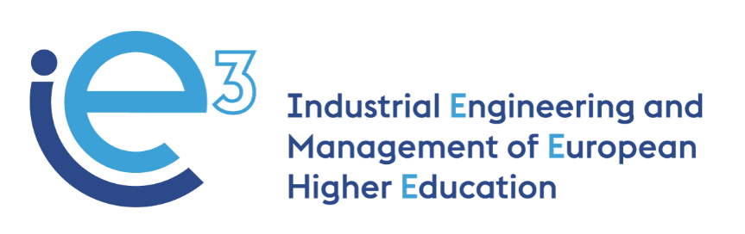



**IE3_17th Virtual Meeting  
19.09.2022**



The European Commission support for the production of this publication does not constitute endorsement of the contents which reflects the views only of the authors, and the Commission cannot be held responsible for any use which may be made of the information contained therein

**Participants:**

* POLIBA, represented by Giorgio Mossa and Francesco Facchini
* PUT, represented by Joanna Oleskow-Szlapka and Agnieszka Stachowiak
* LIU, represented by Janerik Lundquist and Mathias Henningsson
* UPM, represented by Joaquin Ordieres
* VALUEDO, represented by Alessandro Guadagni
* IMPLEMA, represented by Jens Wallgren
* ARRUTI, represented by Carlos Uruena
* BOSCH, represented by Vincenzo Ciannamea
* UNIBA, represented by Giovanni Mummolo

**Agenda:**

* Finalization of WP4 (UPM)
* Update on the work for WP5 (LiU)
* Preparing Stockholm meeting (13-14 Oct 2022) (LiU/Implema)
* News on the Final conference organization (PoliBa)

**Finalization of WP4**

Ordieres (UPM) presents the data from the Polish students completing the three e-learning pilot courses. Oleskow-Szlapka (PUT) knows that more students than the ones considered in the slide presented by Ordieres took the course: the problem could be that some of them have not completed all the assignments and/or have not completed the compulsory survey. However, in order to get more feedback from the learners, PUT team will propose again to their students to take the e-learning courses.

LiU team, which at the moment has reached 0 students for the pilot courses, will propose their students take the courses in October. The deadline for completing the courses for Swedish students is 31.10.2022, after that date, the WP4 pilot courses will be concluded anyhow.

Ordieres (WP4) reminds the partners of the last steps for concluding WP4, especially the completion of the due reports, which is expected by the end of September. Lundquist (LiU) asks Ordieres (UPM) to revise the documents submitted by LiU team and to inform him of what is missing.

Alessandro (Valu) reminds all Universities to revise the e-learning courses by **30.09.2022**, considering the specific feedback and the agreed corrective measures defined in Madrid. The final version of the courses should be sent to Ordieres (UPM) for being uploaded on the IE3 Moodle platform.

**Update on the work for WP5 (LiU)**

Lundquist (WP5) recaps the 5 steps agreed upon in Madrid. The partners thoughtfully discuss the action points and come up with a new plan:

**First phase:**

* All partners are to read the “**The Hallmark of Higher Education Programs in Industrial Engineering and Management**” as a preparatory activity for the following steps.
* Each University partner together with the National industrial partner(s) check the list of course modules of the Master’s programs presented by the partners in Madrid (all the documents are available [here](https://drive.google.com/drive/u/0/folders/1L9FEadCns99oI733B91S0zJJYmb0qn-K)), and propose, if necessary, based on impression and inspiration from the content of the other Master’s programs, new course modules for a revised and forward-looking Master’s program in IE&M. More in detail the partners can find at this link each of the Master’s programs proposed by the partners:
  + LiU: <https://docs.google.com/presentation/d/1-9F90F3OAuniRe0q5KhoE8hwz4sYFrvm/edit?usp=sharing&ouid=107615351270209391491&rtpof=true&sd=true>
  + PoliBA/UniBA: <https://docs.google.com/presentation/d/1SeaYdZJS0uRLXB-mjqvygFA-Cam1W7hx/edit?usp=sharing&ouid=107615351270209391491&rtpof=true&sd=true> and <https://docs.google.com/document/d/1c_ko-xob9hn1kdwju6CSwc2pYKDbTgM5/edit>
  + UPM: <https://drive.google.com/file/d/1VlVoczggSJlwZAW_De6SKFRkoZ7nOyS9/view?usp=sharing>
  + PUT: <https://docs.google.com/presentation/d/1l3nZEpeumyCbTpl9071T0iEtmesD5Lp_/edit?usp=sharing&ouid=107615351270209391491&rtpof=true&sd=true>

* Each University partners together with the National industrial partner(s), to identify, based on all proposed and revised course modules and taking the BoK into account, knowledge blocks or subject clusters that can characterize the different course modules. Examples of such knowledge blocks can be found [here](https://miro.com/app/board/uXjVOmcb18o=/?userEmail=aleguadagni@gmail.com&shareBoard=agnieszka.stachowiak.put@gmail.com&track=true&utm_source=notification&utm_medium=email&utm_campaign=request-for-edit-access&utm_content=give-access&invite_entry_point=board&flow_feature=edit_comment_board&flow_type=request). Identify each block/cluster with a description of 10-15 sentences.

WP1 paper prepared by PUT is here: <https://drive.google.com/file/d/1rjZJkRLzdYR6I6ZOzReGk4so0yj3ef5o/view?usp=sharing>;

The BoK is here: <https://drive.google.com/file/d/1rjZJkRLzdYR6I6ZOzReGk4so0yj3ef5o/view?usp=sharing>

The University partners are free to organize their work with the National industrial partner(s) and have to send the outcomes to Alessandro (Value) who will circulate them among the partners.

Deadline for the first phase: **06.10.2022**

**Second phase:**

* In Stockholm, all partners will jointly revise the work done and will come up with the first draft for a new Master’s program in IE&M

The Stockholm meeting will take place on **13 and 14 October 2022**.

**Preparing Stockholm meeting (13-14 Oct 2022)**

The partners agree to dedicate 2 full days (from 9.00 to 17.00) to the meeting. Most of the agenda will be dedicated to WP5.

**News on the Final conference organization (PoliBa)**

Giorgio confirms that the IE3 International Conference will take place in Bari on **Tuesday 02.02.2023**. The doodle that will be sent out by Valuedo is for defining the date of the partnership meeting – one day before or one day after the Conference.