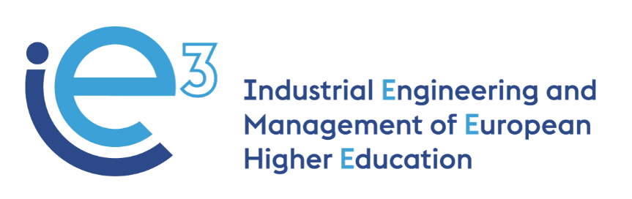



**IE3_18th Virtual Meeting  
29.11.2022**



The European Commission support for the production of this publication does not constitute endorsement of the contents which reflects the views only of the authors, and the Commission cannot be held responsible for any use which may be made of the information contained therein

**Participants:**

* POLIBA, represented by Giorgio Mossa and Francesco Facchini
* PUT, represented by Joanna Oleskow-Szlapka and Agnieszka Stachowiak
* LIU, represented by Janerik Lundquist
* UPM, represented by Joaquin Ordieres
* VALUEDO, represented by Alessandro Guadagni
* ARRUTI, represented by Carlos Uruena
* UNIBA, represented by Giovanni Mummolo
* INFOTECH, represented by Gianluigi De Pascale
* ALCO_MOT, represented by Hanna Golas

**Agenda:**

* Updates on R5.1 “IE3 Master’s Program based on the BoK guidelines” (dl for finalization: 06.12.2022) (LiU)
* Updates on R5.2 “IE3 model Courses Handbook”(dl for finalization: 15.12.2022) (LiU)
* Validation of the evaluation questionnaire for external experts on R5.1 (UPM)
* Validation of WP3 and WP4 materials with the correct visual identity (ValueDo)
* Updates on the organization of the Final Conference (PoliBa)
* Exploitation and sustainability strategy (InfoTech)

**Updates on R5.1 “IE3 Master’s Programme based on the BoK guidelines” and updates on R5.2 “IE3 model Courses Handbook”**

Lundquist (LiU) shows the first draft of the Handbook, including also the IE3 Master’s Programme. Due to a misunderstanding, the document wasn’t shared with all the partners, so only PoliBa, UniBa and ValueDo could read and comment on it.

Mummolo (UniBa) agrees on the structure of the Handbook as it was suggested by LiU. He informs the partners that they have already provided some feedback to LiU, mainly concerning the importance of offering in R5.1 only one proposal for a renewed Master’s Program and, just in case the partner think it would be useful, to add other possible solutions.

Lundquist (LiU) says that the main contents of the Handbook should be those already included in the document. Mossa (PoliBa) and Lundquist (LiU) suggest to include also a one-page description of the main results (of WP1, WP2, WP3, and WP4) with links to the relevant documents prepared by the partnership in the previous 3 years.

The partners agree to deliver just one proposal for the new IE3 Master’s Program, sharing the responsibility for providing the titles of the possible modules, the syllabi and the learning outcomes among the University and company partners. All the partners agree. For the completion of R5.1, the partners should first check the [IE3 Master Program proposal](https://docs.google.com/document/d/1-MBOGn17T54F3wiKGFEzRTdhwuOwyN3p5hob12ksdPI?authuser=aleguadagni%40gmail.com&usp=drive_fs). Then they should comment directly on that file and provide any suggestions (e.g. changing the name of one module, contents, topics, etc.). Finally, for each of the modules assigned to the partners (check the column "Keys, Characteristics and Syllabus by Partner"), they should complete the "module syllabus", following the [example provided](https://docs.google.com/document/d/12qnieHz_PDUlC3xgENXQfNdQ9auFrxvf?rtpof=true&authuser=aleguadagni%40gmail.com&usp=drive), creating one separate document for each module following the example and store in the [same folder](https://drive.google.com/open?id=12gH4OGv7MXwp3v49GCYs0_lIfmzlY-Cp&authuser=aleguadagni%40gmail.com&usp=drive_fs).

**Workplan:**

* All the partners are to revise the IE3 Master program proposal and prepare the “module syllabus” by 06.12.2022
* All the partners are to revise the work by the other partners by 09.12.2022

**Validation of the evaluation questionnaire for external experts on R5.1 (UPM)**

As soon as UPM would have received the first proposal for R5.1, Ordieres (UPM) will prepare the first version of the evaluation questionnaire to be submitted to the external evaluators. The partners would revise the questionnaire following the deadline to be decided by UPM. All the partners are aware that the external evaluation process should be completed by the end of the year 2022, so it should start as soon as possible.

**Validation of WP3 and WP4 materials with the correct visual identity (ValueDo)**

Guadagni (ValueDo) reminds the importance of revising the training materials prepared for the project.

He reminds the partner to complete the task already communicated by email. The deadline for the task is 15.12.2022.

All the instructions for the revision process are listed here below:

1.      **Slides (for both WP3 and WP4) do not include the program's visual identity**.

Solution:

a.      You can use the official template (here attached), including the title of the lesson on the cover page

b.      You can use only the cover page of the official template, including the title of the lesson on the cover page, replacing the previous cover page

c.      You can include on the cover page of your presentations at least the three visual elements as included in the second-page slide of the ppt attached. You can use it as a sort of banner to copy and paste on your slide.

2.      **Videos do not include the program's visual identity**.

Solution:

a.      You can edit the video including the cover page of the official template, including the title of the lesson on the cover page

b.      If the video is uploaded on YouTube, you can include the official template as the thumbnail of the video. In this case, you can just take the cover page of the official template and include the title of the lesson on the cover page. To include this cover as a thumbnail you should follow this procedure:

i.     Sign in to YouTube Studio.

ii.     From the left menu, select Content.

iii.    Click the video you’d like to edit.

iv.     Click Upload thumbnail to create a custom video thumbnail from an image on your device (in our case you should upload the cover page with the title of the lesson and all the visual         elements needed - EU logo, disclaimer, IE3 logo)

v.     Click SAVE.

For more info on this, you can check here: <https://support.google.com/youtube/answer/72431?hl=en>

* **For WP3 materials**: please **upload the revised version of the learning materials in this folder**: <https://drive.google.com/open?id=18_49MnEi325iGBH4_WKwyQBD7hAJRngG&authuser=aleguadagni%40gmail.com&usp=drive_fs>
* **For WP4 materials**: please **upload the revised version of the e-learning materials in the UPM Moodle platform**, and then we will download the zip file.

**Exploitation and sustainability strategy (InfoTech)**

De Pascale (InfoTech) presents the first proposal of the sustainability plan. The partners are invited to complete the document that will be shared by Gianluigi as GoogleDoc with the missing information by 15.01.2022.

**Updates on the organization of the Final Conference (PoliBa)**

Mummolo (UniBa) informs that professors Browne (Galway University) and Sihn (Fraunhofer Wien) confirmed to participate in the conference. Also, one representative of ESTIEM will take part in the project. Before the Conference, PoliBa would share with them the Bok, the IE3 Master’s Program and the Handbook.

The full program of the event would be shared by 10.12.2022. PoliBa will also prepare an invitation letter for getting some virtual attendees.

Finally, Mossa (PoliBa) informs the partners that he sent an abstract for the conference INTED2023 dedicated to presenting the outputs of the Handbook. All the partners were included as co-authors. He will contact the partners to ask for some small contributions.