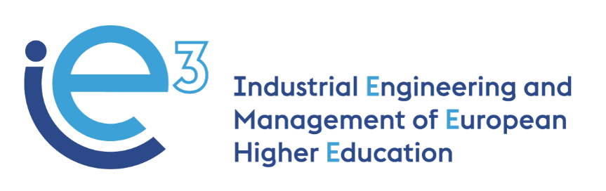



**IE3_19th Virtual Meeting  
12.01.2023**



The European Commission support for the production of this publication does not constitute endorsement of the contents which reflects the views only of the authors, and the Commission cannot be held responsible for any use which may be made of the information contained therein

**Participants:**

* POLIBA, represented by Giorgio Mossa and Salvatore Digiesi
* PUT, represented by Agnieszka Stachowiak
* LIU, represented by Fredrik Persson
* UPM, represented by Joaquin Ordieres
* VALUEDO, represented by Alessandro Guadagni and Stefano Pianigiani
* ARRUTI, represented by Carlos Uruena
* UNIBA, represented by Giovanni Mummolo
* Tecnologie Diesel, represented by Paolo Ciannamea
* IMPLEMA, represented by Jens Wallgren

**Agenda:**

* External evalaution of R5.1 (UPM)
* Next steps for finalization R5.1 (LiU)
* Validation of R5.2 (LiU)
* Updates on the Final Conference (PoliBa)
* Revision of the contributions for the sustainability and exploitation plans (InfoTech)
* Recap on the documents to prepare for the Technical Final Report (Valuedo)

**External Evaluation of R5.1 (UPM)**

UPM team reports on final phases of R5.1, after collecting the draft from LIU team. A form was created accordingly and shared with all partners. It is understood that all collated information is positive and further actions are therefore not expected. UPM team also advises that the previous outcome report 8.1 has been updated to reflect most recent data available. Ordieres (UPM) will correct the affiliation of Mummolo (UniBa instead of PoliBa).

VALUEDO confirms that external reviewers have looked into the documents previously shared by LIU team and made no observations.

**Next steps for the finalisation of R5.1**

The document is finalized and it is available [here](https://docs.google.com/document/d/14d0t2LTHRFam_FMfgxy-55RmVtfHFvNI?rtpof=true&authuser=aleguadagni%40gmail.com&usp=drive_fs). It is composed of the proposed Master Program and the full description of the Syllabi. All partners are expected to check the module syllabi and the description to ensure the coherence of the information included in the table. The deadline for revising the document is Friday 13.01.2023.

With regards to feedback received in relation to the master’s programme, this is only partial and it is considered that additional data is needed. LIU team suggests that the chance to provide feedback (especially on what it is written under the heading “Keys” and “Characteristics” in Table 1 to 4) be kept open until 14.01.2023, so that final output is then provided to POLIBA by end of 16.01.2023.

**Validation of R5.2**

POLIBA team presents the final version of the Handbook ([here](https://docs.google.com/document/d/14hI-3SFxbjEkkSNwZ_Ni6PLaLMV26r_1?rtpof=true&authuser=aleguadagni%40gmail.com&usp=drive_fs)) and asks that LIU team use the most recent version of the document, which is available on GDrive, for further contributions (once final data is available). The current version has been proof-read by VALUEDO team. POLIBA also stresses that this document is lean and intentionally so, as it is thought of as a guide for whoever may want to refer to for implementing a course in IE&M. In fact, the structure is exactly the same as the one that partners approved at the last physical meeting in Stockholm. The content of the Section 4 “A new master program” is the same of the document R5.1.

Links to the documents developed during the project implementation (e.g. the questionnaires used for the training need analysis, the training materials and the e-learning contents developed) are included within the Handbook, so that they are easily accessible if this is accessed online.

The deadline for revising the document is Friday 13.01.2023.

**Updates on Final Conference (POLIBA)**

The organisation of the conference is almost complete. Partners have received the flyer and are now asked to disseminate the information about the conference. Partners are also invited to share the Facebook and Linkedin posts for enhancing chances of higher attendance to the conference. It is important to share that it is necessary to get people registered to the conference. POLIBA team stresses the importance of using the final version of the conference flyer (which was shared during the meeting), because this contains the QR code linked to the registration link. This is the tool that POLIBA team is using to keep track of the number of attendees. Therefore, even though people can watch the conference for free on POLIBA’s YouTube channels, they should be invited to register nonetheless.

UPM team raises concerns in respect of first panel of the conference, in that there is a risk that there may be an overlap between the three presenters. UPM suggests that roles are clearly defined in order to avoid unnecessary duplications. POLIBA team advises that it is expected that:

* PUT will tackle the training needs analysis;
* UPM will follow it up with a presentation of technical learning tools and methodologies;
* POLIBA will conclude with a presentation of the final handbook.

Each speaker is allocated no more than 20 minutes. Alessandro will share a template to use for the ppt presentation ([here](https://docs.google.com/presentation/d/14mLVKyecHP_Rzpk70rtQDoOFEj8-mcvS?rtpof=true&authuser=aleguadagni%40gmail.com&usp=drive_fs)).

UPM team further asks how POLIBA team is going to keep a track-record of people in physical attendance. POLIBA team replies that the most appropriate way is to set up a registration desk.

Partners are invited to check and complete the following document:<https://docs.google.com/spreadsheets/d/1AFjU_5eg_JPurW-B7pp9k-063gjMHuDIgMunEaOzC9E/edit?pli=1#gid=0>

**Revision of the contributions for the sustainability and exploitation plans (InfoTech)**

InfoTech is not in attendance. VALUEDO team presents briefly the Dissemination and Exploitation plan. Mummolo (UNIBA) stresses the importance of translating all available materials and data into English.

**Recap of documents to prepare for the Technical Final Report (Valuedo)**

VALUEDO team advises partners as to the elements of the report and reminds everybody that the deadline for submission is the end of this month of January 2023. Relevant emails have already been dispatched, therefore it is expected that partners are going to complete the tasks assigned to them (if any and where relevant).