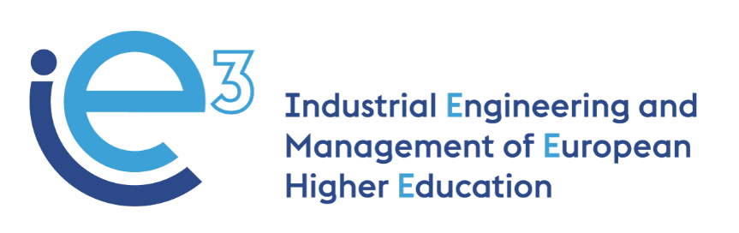



**IE3_12th Virtual Meeting  
30.09.2021**



The European Commission support for the production of this publication does not constitute endorsement of the contents which reflects the views only of the authors, and the Commission cannot be held responsible for any use which may be made of the information contained therein

**Participants:**

* POLIBA, represented by Giorgio Mossa and Salvatore Digiesi
* PUT, represented by Agnieszka Stachowiak and Joanna Oleskow-Szlapka
* LIU, represented by Janerik Lundquist and Mathias Henningsson
* UPM, represented by Joaquin Ordieres
* VALUEDO, represented by Alessandro Guadagni and Giuditta Pasta
* BOSCH TDIT, represented by Felice De Stena
* INFOTECH, represented by Gianluigi De Pascale
* IMPLEMA, represented by Eskil Rehme
* ARRUTI, represented by Carlos Uruena
* Invited: UNIBA, represented by Giovanni Mummolo

**Agenda:**

* Ratification of the inclusion of the University of Bari in the IE3 consortium (PoliBa).
* Updates on WP3 courses
* Presentation of R4.1 and R4.2 (UPM);
* Planning next WP4 activities (UPM);

**Ratification of the inclusion of the University of Bari in the IE3 consortium (PoliBa)**

As already communicated by email, Giovanni Mummolo, former project coordinator, is now working for a different University, the University of Bari. PoliBa asked him to join the partnership with the new University and the University of Bari accepted the proposal. Also, the partners had all formally agreed by email on the inclusion in the consortium of the new partners, which is expected to strengthen the outreach of the project and enrich the target of numbers to test the WP4 courses. The total budget of the project will remain unchanged, as well as each budget’s partner; only PoliBa reduces its share to allow UniBa to fully join the consortium. PoliBa informs the partners that the official amendment request for the new partner will be sent to the Agency in the following days.

All the partners congratulate the new project coordinator, prof. Giorgio Mossa (PoliBa), who is also going to represent the partnership with EACEA in the next months before the end of the project.

**Updates on WP3 courses**

Before starting with the presentation and discussion on WP4 activities, the University partners give an update on the progress of the courses.

* UPM is now implementing the renewed course, which has a blended approach, already taking into consideration asynchronous training. The students are more than 70 and they are already working hard on the different assignments. The course will be completed by December 2021. Joaquin (UPM) will be able to share all the modules they have tested.
* PUT redesigned the course with ALCO-MOT during summer and introduced elements related to the real needs of the companies and new methods. The two courses are traditional and contemporary Manufacturing Systems, based on ALCO-MOT’s experience, which is already mixing two types of manufacturing: automatic part and manual part. The course will start next week (on the 4th of October) and it will be completed by December 2021. The course is delivered as in-person training and they will organize also a field visit in ALCO-MOT. The second course is “Supply chain Management for Sustainability of the Company”, also taking into consideration good practices of Alco-Mot. They present the reverse flow and the importance of suppliers under both a quantitative and qualitative point of view, in the era of broken supply chain and COVID. The students will be asked to complete projects. The courses are fully in English.
* LIU will start the course in Autumn. Janerik reminds the partners to provide LiU the documents agreed on before starting the courses.

**Presentation of R4.1 and R4.2**

Ordieres gives the partners the presentation available at [this link](https://drive.google.com/open?id=1gTu3wCy6GcahMOr_DbhRRd7eyXrjUBIf&authuser=aleguadagni%40gmail.com&usp=drive_fs).

* **R4.1 Memorandum on technical criteria for the development of e-learning modules and requirements of the technical environment;** Ordieres explains that UPM produced a document in which the main technical requirements and features for both the e-learning modules to be developed by the partners and the environment where to store them are described. Indeed, a common live testbed for implementation was provided with access rights to the partners according to their profile. The T4.1 is under the UPM responsibility, however, it would be great to collect some aspects considered as requirements from the approach you want to use, in order to have a common view and a useful testbed for usage.  
  Only LIU has provided few details up to now. Then UPM moved forward to create the promised deliverables.
* **R4.2 E-learning Pedagogical Strategy.** The Report describes the best pedagogical practices to be followed for the preparation of the e-learning modules. It will contain guidelines and practical information for the partners to develop the e-learning modules. UPM brought its ideas as a reference (microlearning+ knowledge-based graph for theoretical learning + competence-based collection system + practical implementation) meanwhile other partners contribute according to their view.

Ordieres (UPM) encourages partners to provide opinions, variants or alternatives or improvements during October (deadline for this task).

**Planning WP4 next activities**

Ordieres asks for receiving information on the name of the course, the name of the trainers in order to update the e-learning platform already available online.

Partners decide that:

* the expected workload for the students (taking the course and autonomous work) should be between 4 and 8 hours
* a common evaluation system has to be established
* the partners should include in the training materials some quizzes, to assess the knowledge acquired by the students

In the coming months, the partners should discuss the possible topics to be addressed in the e-learning. UPM suggests that by the end of the year 2021 the partners should define the topic to be developed, the title of the module and the first draft of its contents.

Mossa (POLIBA) suggests that at this point it is very crucial, before defining the e-learning course contents, to finalize and approve the work done for WP3, so as to allow each partner to understand what the other partners are doing and have done. For this reason, partners are asked to upload in a common folder at the following [link](https://drive.google.com/open?id=1dCyVLePghL-57Yt0XgkiA-ohQ9p2Jgbu&authuser=aleguadagni%40gmail.com&usp=drive_fs) the syllabus of the WP3 courses **by 01.10.2021.**

Afterward, the partners agree that:

* All the partners to read carefully the other partners’ courses syllabus;
* The authors of the materials select the topics they could address in the e-learning course. The proposed topics will be included by the authors in a spreadsheet in the WP4 folder on Google Drive that will be created by UPM as WP4 leader
* Valuedo to send a doodle from 18-22 October to discuss the possible topics for the e-learning modules. During the meeting, the partners will discuss together the most suitable topics proposed by the authors in order to define the final topic(s) to be included in WP4 courses

Ordieres (UPM) asks to complete the evaluation of the WP4 courses by June 2022, so to give the partners more time for the revision of the training materials. Odieres would suggest asking the teachers to evaluate the e-learning courses. The evaluation will be at two levels:

* To evaluate the impact on the students (quizzes or other assignments designed by the trainers; each trainer is free to decide how many quizzes to include);
* To test the efficiency of the training (quality of the training). This second level gives the partners suggestions for the improvement of the training contents.

UPM will analyze the evaluation given by students and trainers for suggesting to the authors the possible points for improvement. The improvements should be done by September.

Next deadlines and workflow:

* The academic partners to provide the requested information for T4.1 to UPM (in the particular module name, professors, etc.) by 01.10.2021
* The academic partners to contribute to R4.2 regarding their specific details for pedagogical approach, when different from the already included by UPM by 20.10.2021