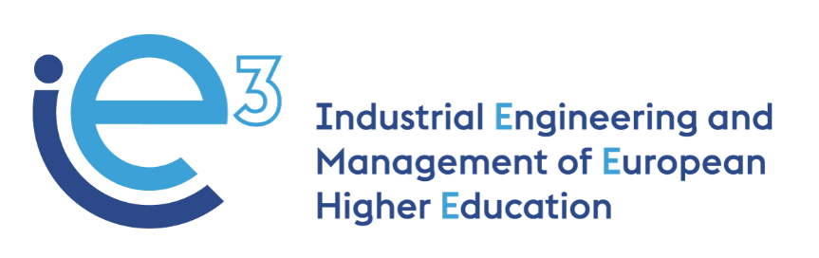



**IE3_16th Virtual Meeting  
08.04.2022**



The European Commission support for the production of this publication does not constitute endorsement of the contents which reflects the views only of the authors, and the Commission cannot be held responsible for any use which may be made of the information contained therein

**Participants:**

* POLIBA, represented by Giorgio Mossa, Salvatore Digiesi and Francesco Facchini
* PUT, represented by Joanna Oleskow-Szlapka
* LIU, represented by Janerik Lundquist, Mathias Henningsson and Fredrik Persson
* UPM, represented by Joaquin Ordieres
* VALUEDO, represented by Giuditta Pasta
* IMPLEMA, represented by Robert Roslund and Jens Wallgren
* ARRUTI, represented by Carlos Uruena
* BOSCH, represented by Vincenzo Ciannamea
* UNIBA, represented by Giovanni Mummolo

**Agenda:**

* WP4: organization of the pilot courses with students and company partners – UPM;
* WP6: organization of next meeting in person (16-17 June) – All partners;
* WP5: presentation of WP5 activities – LIU;
* WP9: planning of the final international conference in Bari – All partners.

**WP4: organization of the pilot courses with students and company partners – UPM**

Each University partner shows the progress of the preparation of its module. All the university partners will ask their students to pilot the courses:

* Mossa (PoliBa) shows the situation on the platform. PoliBa and UniBa just need to upload the final videos and the course will be completed; afterward, they will open the self-enrollment for the students. The students will be provided with a link and they will be integrated into the module directly.
* Ordieres (UPM) specifies that UPM will include the list of students provided by the universities in the Moodle so that every teacher can see the students that will participate. The module prepared by UPM is completed.
* Lundquist (LIU) informs that LIU will complete the quizzes with the help of Implema shortly. The module, including the quizzes, will be ready on 19.04.2022.
* Oleskow-Szlapka (PUT) adds that PUT is finalizing the quizzes that will be ready by 11.04.2022. PUT has two modules, but the only one that will be finalized and officially present in the platform is one.

PoliBa and UniBa will conduct the pilot courses in the next weeks. UniBa offered the opportunity to follow the course to their students and is waiting for their replies. PoliBa has gathered 18 students for the modules of LiU and UPM and is still looking for students for the PUT module. The Moodle allows downloading the performance of the students on the quizzes. Mossa (PoliBa) reminds us that it is important that all the students complete the mandatory assessment for evaluating the quality of the course.

The expected dates for the pilot with the students are the following:

* PoliBa and UniBa: May 2022;
* PUT: April – May 2022;
* LIU: May 2022;
* UPM: From 21.03.2022 until mid of May.

ValueDo creates a matrix where the University partners are asked to indicate the number of students attenting the pilot of the course. The documenti s available here: <https://docs.google.com/spreadsheets/d/1UQvxs-TGP3ZEM7RShBb0lgdbNvJs-wHy1WbuUkWaYGU/edit?pli=1#gid=0>

**WP6: organization of next meeting in person (16-17 June)**

The next in-person meeting of the project will take place in Madrid on 16th and 17th June, hosted by UPM.   
Valuedo will send a google sheet ([here](https://docs.google.com/spreadsheets/d/1MUyn4XdSlILxr4ONNJvtGu1QWVSlh6GhZ_oMwlGixIg/edit?pli=1#gid=0)) for the partners to indicate the names of the people that will attend the meeting, and UPM will send all the logistics information regarding accommodation and travel connections. Lundquist (LIU) proposes to ask for an extension of the project of 3 months. This request is linked to the fact that the project activities did not go exactly as planned in the project application (mainly the organization of meetings in person) due to the difficulties and travel restrictions because of covid19 and to the possibility that the activities of WP5 will probably need more time for an efficient and proper implementation.

Mossa (PoliBa), as scientific coordinator of the project, will consider this possibility and eventually propose the issue to the Project Officer.

**WP5: presentation of WP5 activities**

Lundquist (LIU) presents the plan for WP5 activities (the full presentation is [here](https://docs.google.com/document/d/1X0VvFhKViv0cC58fif-u5-uI7ejoOB-5/edit?usp=drive_web&ouid=115321187131052982567&rtpof=true)).

The proposed action is the following:

* Each university partner in collaboration with the industry partners will design a proposal of a renewed MSc programme in IE&M for tomorrow based on what has been developed so far in the project and related to local experiences and identified needs in the national industry.
* The programme must be a blended learning programme with both traditional learning and teaching activities and newly developed e-learning modules.
* The first academic year is an undivided period without possible specializations.
* The third semester (second year) can be a continuation of the format from the first year or be split into two or more content directions.
* The Master’s thesis is equal to 30 ECTS and must be scheduled for the fourth semester.
* Each university partner will illustrate the programme proposal with a course diagram.
* For each course module, the partners must indicate their full name, number of ECTS (normally 4-6 per module), and a short presentation of the content of the module (not a complete module presentation at this stage).
* If they want to divide the third semester into specialisation branches they will have to explain why.
* Sort out the entry requirements for the proposed programme.
* Specify which course modules are brand new, revised existing and existing modules respectively.
* **All University partners to send their proposal by 07.06.2022.**
* The proposals will be presented during the June coordination meeting in Madrid.
* A special working seminar to finalise the new programme is proposed to be arranged in late August or early September well ahead of the final conference.

Ordieres (UPM) says that it could be complicated to make the merge to create a blended learning programme with both traditional learning and teaching activities and newly developed e-learning modules. He proposes to include new rules, and how to accommodate and facilitate the second step. Lundquist (LIU) specifies that for the first stage, it is enough to include the full name of the module, 3-4 lines as a presentation and the number of ECTS (it is not needed to include the syllabus).

Mummolo (UNIBA) points out that the project is looking for a European benchmark to be adopted for a renewed I&EM Master course by other countries and other universities. In WP1 and WP2, the consortium identified the gap analysis. The point is that the consortium should have a European reference to build a master programme for Europe.

Lundquist (LIU) will send an e-mail with WP5 plan to the partners.

LIU will have also a bilateral meeting with InfoTech, which is in charge to develop the Handbook (*T5.3 - Exploiting the new courses and capitalization: the creation of a Handbook for IE3 Courses*). The Handbook will sum up the experiences collected in the four partner countries and address key points to facilitate the adoption of the IE3 methodologies by non-partner HEI and companies.

**WP9: planning of the final international conference in Bari**

The final conference of the project was initially planned for October 2022, but as the partners are considering the possibility to extend the length of the project for a couple of months, the event could take place in the first week of December 2022. Mummolo (UNIBA) thinks that Lundquist (LIU) and Ordieres (UPM) will attend the AIM conference in Ancona (15 – 18 September 2022). It would be possible to ask the colleagues from AIM to provide feedback and suggestion on the work done.