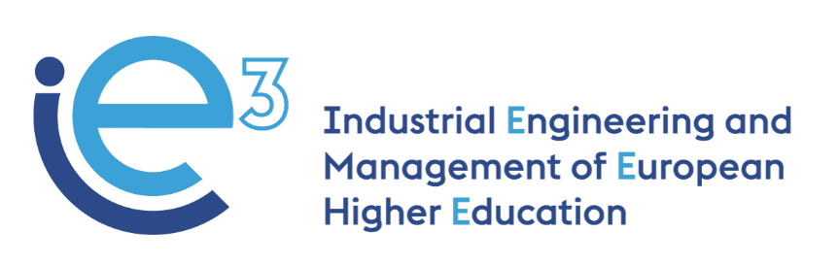



WP 5 – Revising a new educational pathway of IE&M

# Index

Index 2

WP 5 – Revising a new educational pathway of IE&M - POLIBA and UNIBA 3

Aims 3

European Credit Transfer and Accumulation System (ECTS) 3

Focus on 3

Programme Structure 4

Course structure, contents, and teaching methods (proposal) 5

Core Courses – 1st year 5

Major Courses – 2nd year 7

# WP 5 – Revising a new educational pathway of IE&M - POLIBA and UNIBA

IE&M Master programme is multidisciplinary.

Students attending the programme can choose from various courses and teaching methods (theoretical lectures, case studies, project works, and field activities).

The learning experience will involve students in real projects with companies, public bodies, and non-profit organizations, testing the knowledge and skills acquired in the Master.

## Aims

* A renewed MSc programme in IE&M
* A blended programme with the e-learning modules developed by the IE3 partner universities
* Course contents and teaching methodology derived from the IE3 BoK

## European Credit Transfer and Accumulation System (ECTS)

* 2 academic years – 4 semesters (120 ECTS)
* Course modules (90 ECTS)
  + Core courses (60 ECTS – 1st and 2nd semester)
  + Major Courses in 3 Streams or specialization (30 ECTS – 3rd semester)
* Project Internship and Final Thesis (30 ECTS – 4th semester)

## Focus on

* Strong theoretical fundamentals (e-learning part of the modules where possible and needed)
* Learning by doing (LbD) approach (practical industrial cases) training the student softskills
* Full Engagement of Industrial Stakeholders
  + most part of the courses must have a project or case study analysis (LbD) – if possible, in teams and/or in competitive activities (gamification)
  + mandatory internship for the final thesis project
  + modular approach to course creation allows more accessible lifelong learning for Company staff
* Flexible 3rd semester
  + allows personalization of the learning path; students can follow their interests receiving a customized education
  + allows the acquisition of specific knowledge and competencies for the final project work and internship
  + encourage students’ mobility (incoming and outcoming)

## Programme Structure





Different colours highlight specific knowledge areas.

Blue: Business and Management

Orange: Industrial Systems Engineering and Manufacturing Technology

Green: Information Technology and Computer Science



## Course structure, contents, and teaching methods (proposal)

### Core Courses – 1st year





**Management accounting**

Goal: to acquire knowledge on management accounting and related assessment tools

Main topics:

* Financial accounting and management accounting
* Management accounting techniques
* Management control

**Machine Learning**

Goal: to acquire knowledge on algorithms and approaches to design and solve typical Machine Learning problems.

Main topics:

* Learning from Examples – Design of a Machine Learning system
* Linear regression and Logistic Regression
* Non linear classification algorithms
* Support Vector Machine. Neural Networks, KNN
* Statistical learning, Naive Bayesian Classifier, Principal Component Analysis
* SVD, Clustering, K-means, GMM, Outlier detection
* Recommender Systems

**Business Process management**

Goal: to acquire knowledge on business processes properties, management, and mapping techniques

Main topic:

* Business processes and process-based organizations
* Process analysis and re-design
* Business process management life cycle

**Lean Systems**

Goal: to acquire knowledge on lean production and continuous improvement tools

Main topics:

* Lean production basic
* Wastes in production
* Shop floor management
* Pull and leveling
* Production management in a lean plant

**Supply Chain Management**

Goal: to acquire knowledge on supply chain structure, strategy, and organization

Main topics:

* Supply chain management
* Visibility and integration
* Procurement
* Supply contracts

### Major Courses – 2nd year

**Strategy and management**

Goal: to acquire knowledge on the positioning of firms into a market sector and on the strategic behavior of firms

Main topics:

* Company strategy and sector analysis
* Competitive edge and competitors’ analysis
* Value chain and business strategy
* Organizational structures
* Organizations and strategies

**Finance**

Goal: to provide fundamentals of finance and capital budgeting

Main topics:

* Theory of value
* Financial assessment, risk, and capital budgeting
* Funding sources and financial structure

**Marketing and customer analytics**

Goal: to acquire knowledge on strategic marketing and on quantitative models for the evaluation of strategies effectiveness

Main topics:

* The market and the decision process
* Brand and Market penetration
* Market segmentation and cluster analysis
* Market positioning and market actions
* Customer metrics: loyalty, experience, and brand awareness
* Regression analysis

**Advanced Manufacturing in the digital factory**

Goal: to acquire knowledge on innovative manufacturing technologies and on the design of CAD-CAM-PLM systems.

Main topics:

* CNC and DNC machine tools
* servomotors and motion transmission components
* Sensors and measuring systems
* Software CAD/CAM and PLM (Product Lifecycle Management)
* Micro-machining

**Fundamentals of IoT**

Goal: to acquire basic knowledge on Internet of Things technology, protocols, and application fields

Main topics:

* Quality requirements
* TLC services and networks
* ISO-OSI and TCP/IP models
* Application, transport, and network levels: HTTP/FTP/DNS, UDP/TCP, and IP/DHCP/NATS
* IoT for Industry 4.0: IEEE technologies, new IETF protocol stack for embedded internet
* LR-WPAN and LP-WAN

**Innovation**

Goal: to acquire knowledge on innovation processes and strategies to be adopted in order to successfully implement them

Main topics:

* Innovation types and sources
* Innovation projects assessment
* Collaboration strategies
* Open innovation, crowdsourcing and crowdfunding
* Digital transformation